**2.3.2. Teachers use ICT enabled tools for effective teaching-learning process (2020-21)**

**Google classroom / you tube channel /others etc.**

|  |  |  |  |
| --- | --- | --- | --- |
| **Sr.no** | **Name of faculty** | **Nature of e-corner** | **URL link** |
| 01 | Prin. Dr.T.S. Birajdar | Zoom Meeting | **------** |
| 02 | Prof Dr.K. M. Patil | Zoom Meeting | **------** |
| 03 | Prof Dr.C.S.Sukhdane | Zoom Meeting | **------** |
| 04 | Mr V. N. Andhale | Zoom meeting & YouTube | **------** |
| 05 | Dr. B.F. Shaikh | Zoom Meeting | **------** |
| 06 | Dr.A.D.Valvi | Zoom Meeting | **------** |
| 07 | Mr.S.B.Shingane | Zoom Meeting | (<https://meet.google.com/jzv-ebfh-gsb>) |
| 08 | Mr.R.M.Kendre | Zoom meeting & YouTube | <https://youtube.com/channel/UCpFjYp598518PsPQpT4NWnQ> |
| 09 | Dr.V.A.Warde | Zoom Meeting | **------** |
| 10 | Mr.P.R.Deshmukh | **-----** | **------** |
| 11 | Dr.K.D.Mahajan | Google classroom & YouTube | <https://youtube.com/channel/UCVVVmc7XMPDLi--GRMw_CVw> |
| 12 | Mr.D.N.Patil | **-----** | **------** |
| 13 | Mr.S.S.Palkhe | Google classroom & YouTube | (<https://www.youtube.com/channel/UCpTQOpAErVQxZ0XUwBxfMZQ>) |
| 14 | Dr.S.M.Upasani | Google classroom & YouTube | (<https://youtu.be/wiPp5nvbXkQ>) |
| 15 | Dr.D.R.Bonde | Google classroom & YouTube | (<https://youtube.com/channel/UCsI6Wc7aY4cO-jsARBRfLmw>) |
| 16 | Dr.A.A.Joshi | Google classroom & YouTube | (<https://youtube.com/user/yourajaaj>) |
| 17 | Dr.P.S.Borse | Zoom Meeting | **------** |
| 18 | Mr.V.Y.Valavi | Google classroom & YouTube | (<https://youtu.be/MRHQ67lxWQk>) |
| 19 | Mr.G.G.Mahajan | Zoom meeting & YouTube | (<https://youtube.com/user/dongaurav1>) |
| 20 | Mr.A.A.Patil | Google classroom & YouTube | (<https://www.youtube.com/watch?v=ky2w5peQAfo>) |
| 21 | Dr.S.M.Khare | Google classroom & YouTube | (<https://youtube.com/channel/UCfV9rkD8MpLuMSWHhDL0H6w>) |
| 22 | Dr. Jyoti. P.Mahajan | Zoom meeting | **------** |
| 23 | Dr.G.G.Jadhao | Google classroom & YouTube | (<https://youtu.be/2aW_SZvZJ34>) |
| 24 | Mr.D.B.Chavhan | Zoom Meeting |  |
| 25 | Dr.S.H.Waghmare | Google classroom & YouTube | (<https://youtu.be/KGNrBloPpKE>) |
| 26 | Dr.D.K.Gaykwad | Zoom meeting | **------** |
| 27 | Mr.R.P.Kedar | Google classroom & YouTube | (<https://youtu.be/WnuV5t3hp9M>) |
| 28 | Mr.H.A.Bhalerao | Zoom meeting & YouTube | (<https://youtu.be/Yct4exK4fA8>) |

**Teachers use ICT enabled tools for effective teaching-learning process*.***

**You Tube Channel**

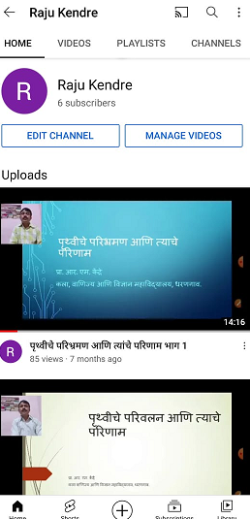 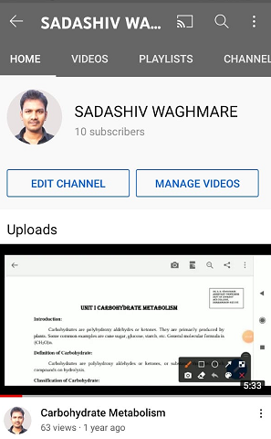

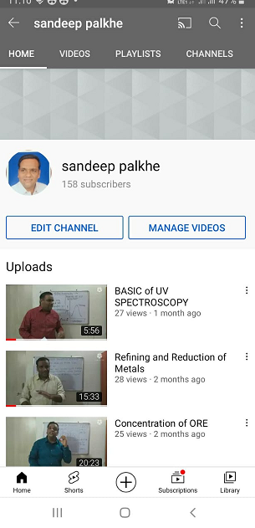 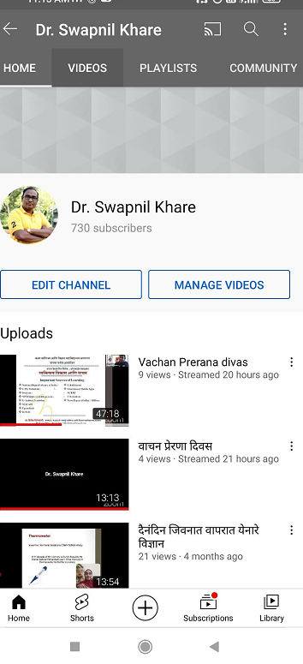

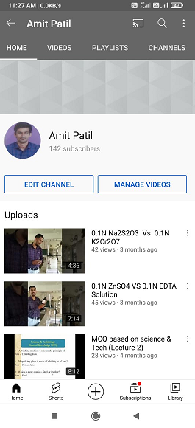 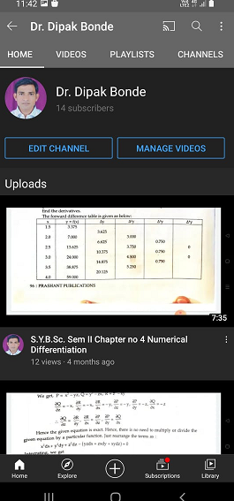

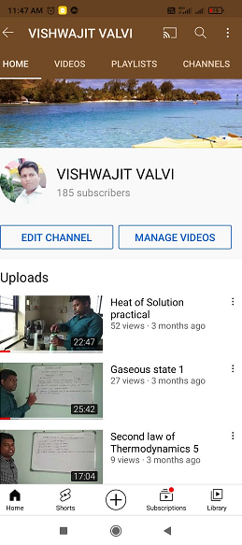 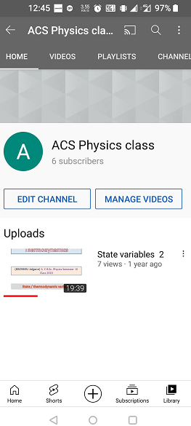

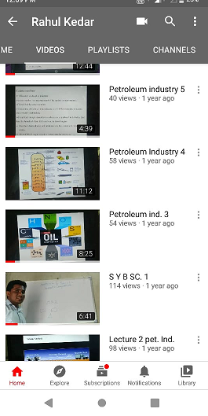 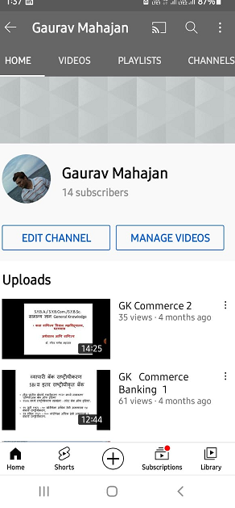

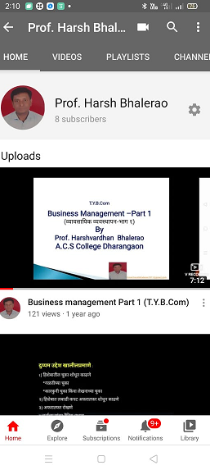 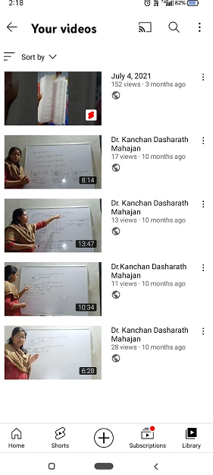

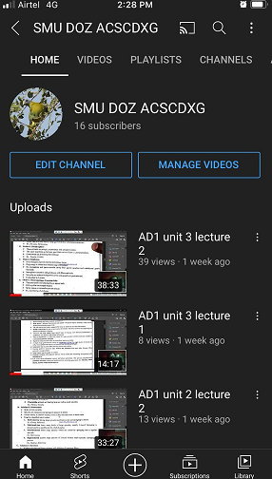

**Google Classroom of Mr. S. S. Palkhe Sir**

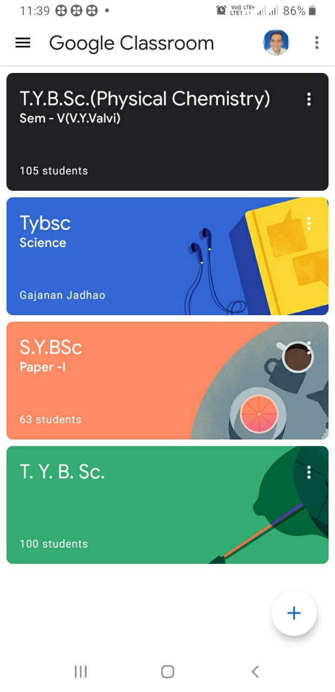

**Google Classroom of Mr. V. Y. Valvi**

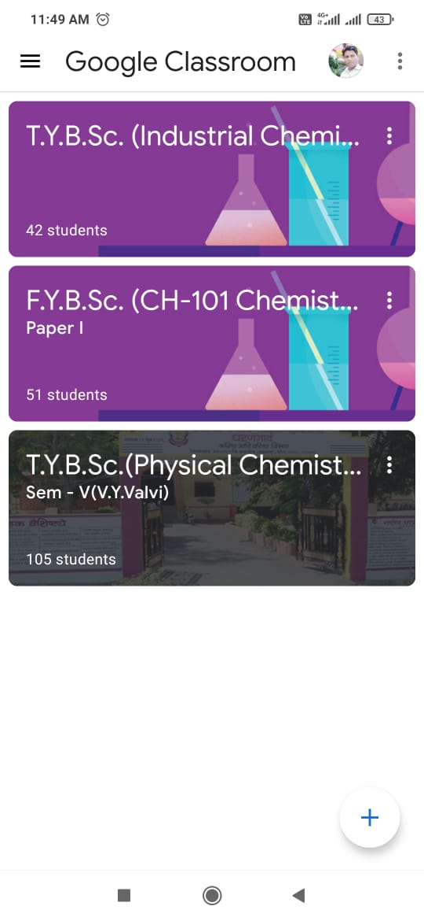

**Google Classroom of Dr. G. G. Jadhao**

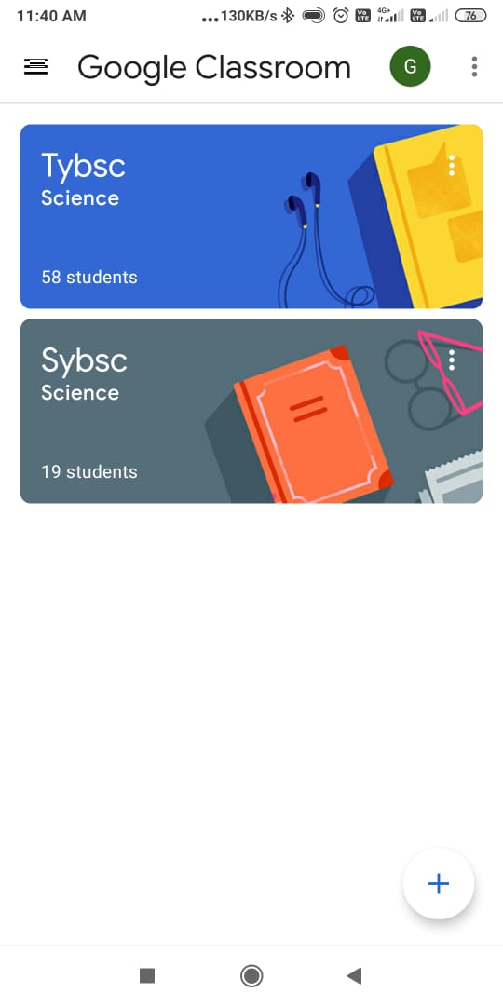

**Google Classroom of Mr. R. P. Kedar**

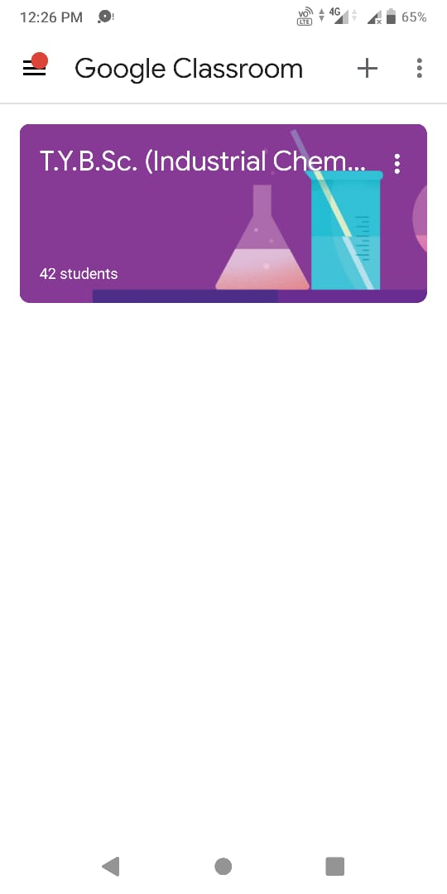

**Google Classroom of Mr. A. A. Patil Google Classroom of Dr. S. M. Upasani**

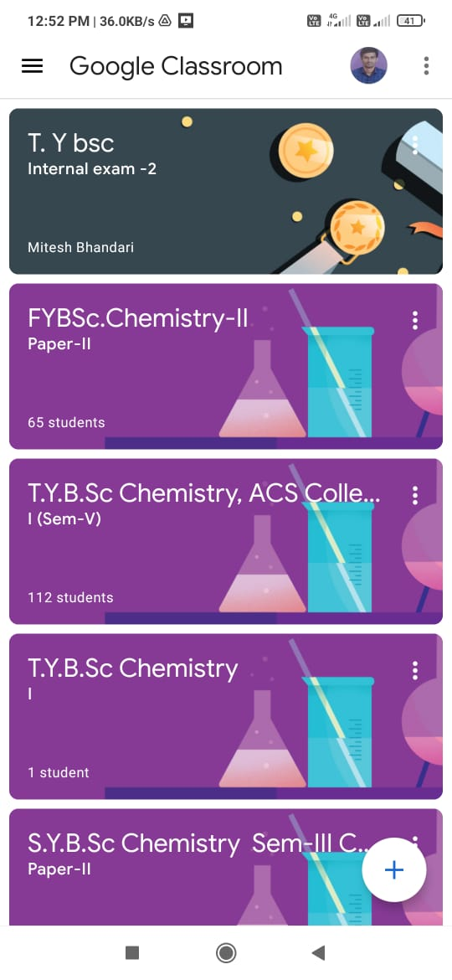 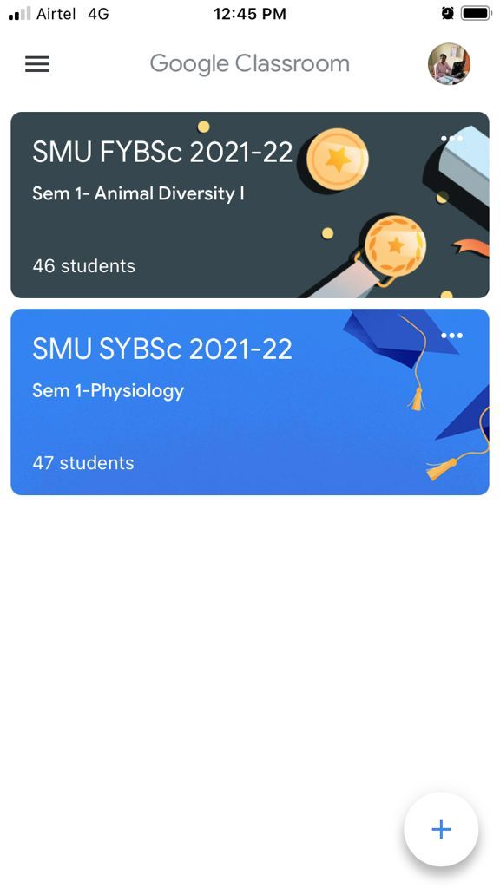

**.**

**Google Classroom of Dr. S. H. Waghmare**

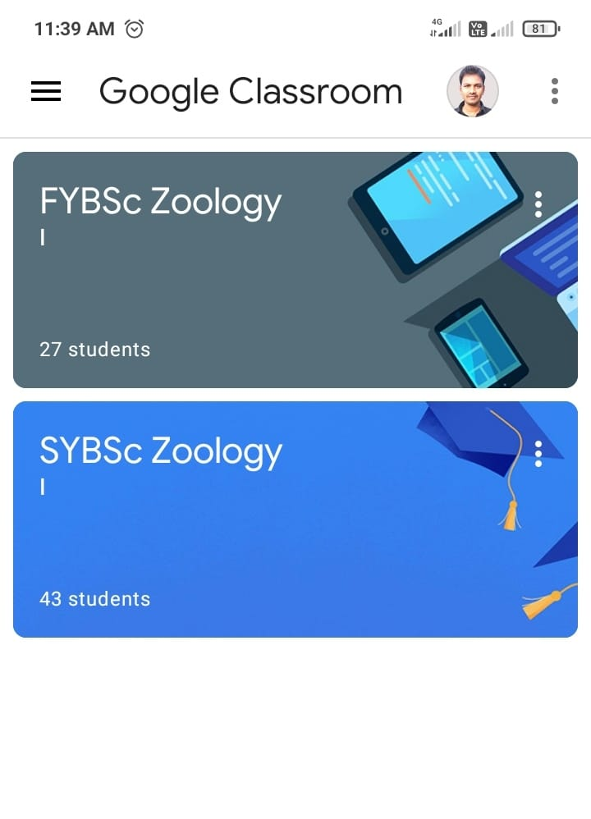

**Google Classroom of Dr. S. M. Khare**

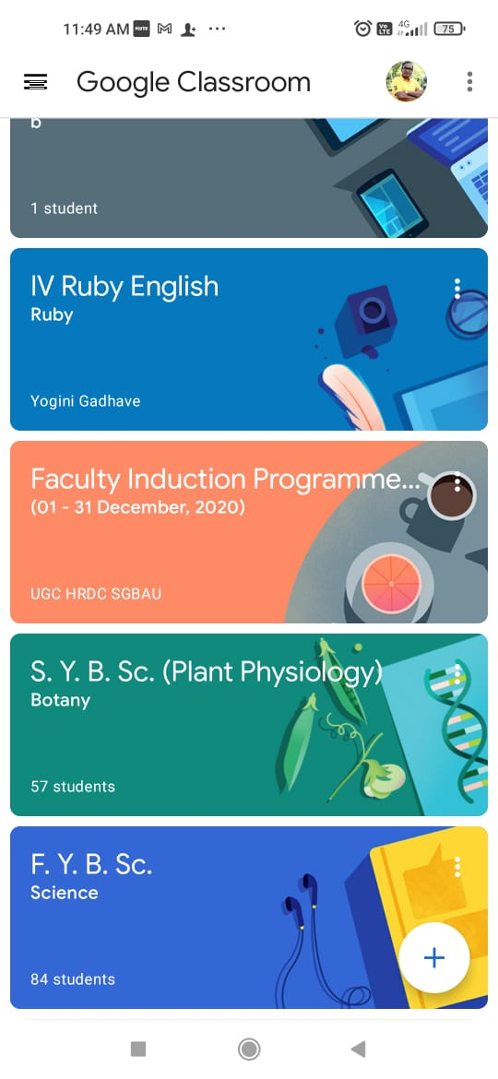

**Google Classroom of Mr. D. B. Chavan**

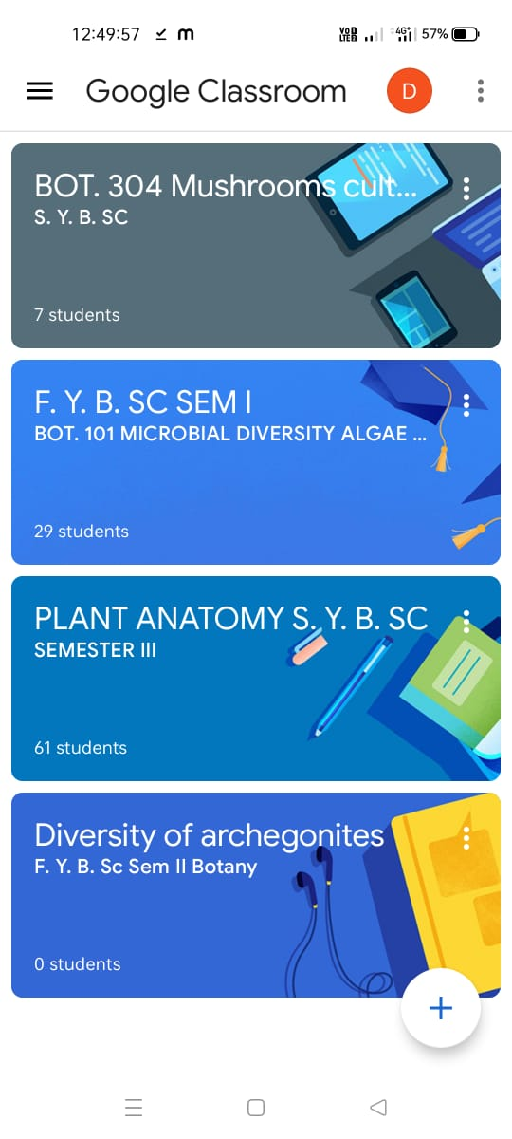

**Google Classroom of Dr. A. A. Joshi**

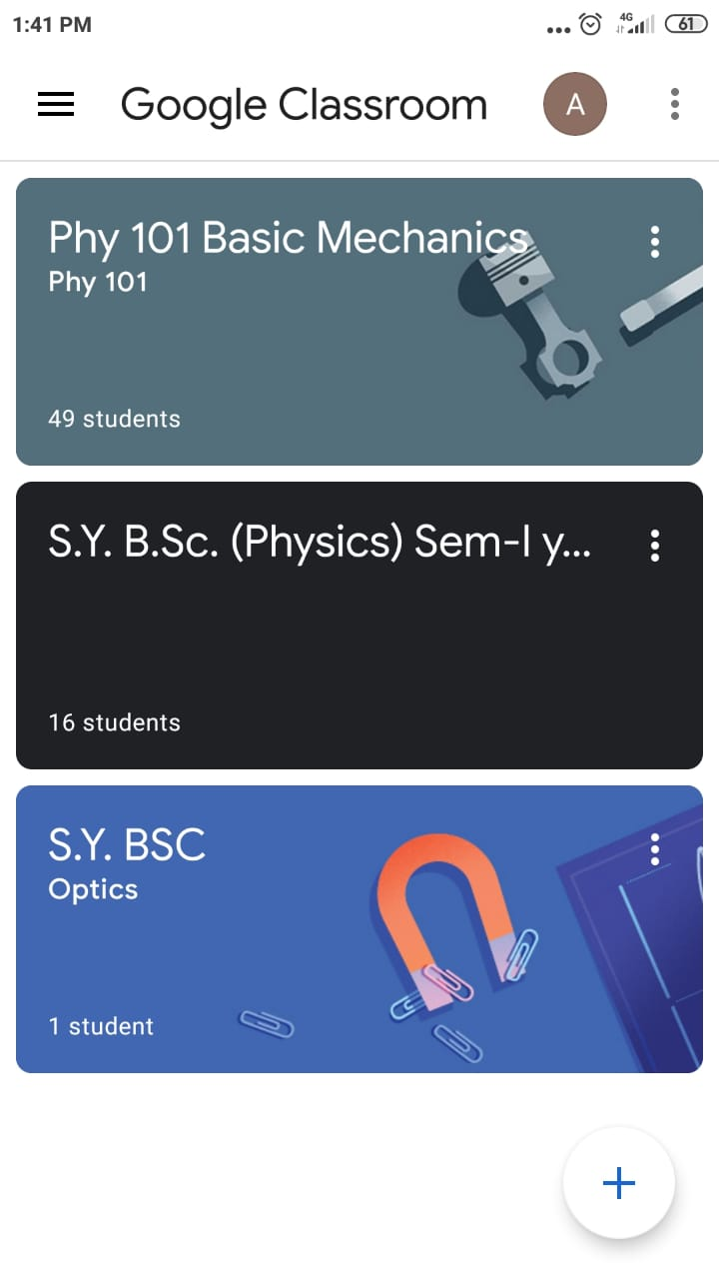

**Google Classroom of Dr. D. K. Gaikwad**

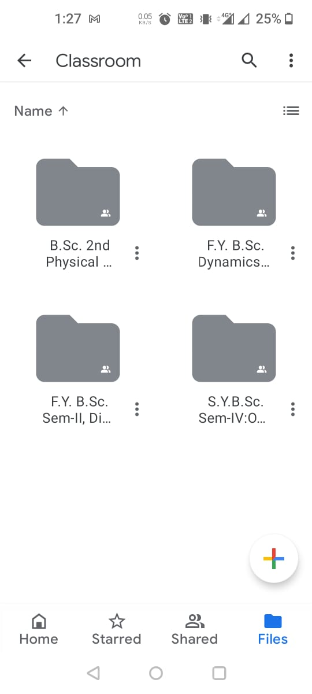

**Google Classroom of Mr. H. A. Bhalerao**

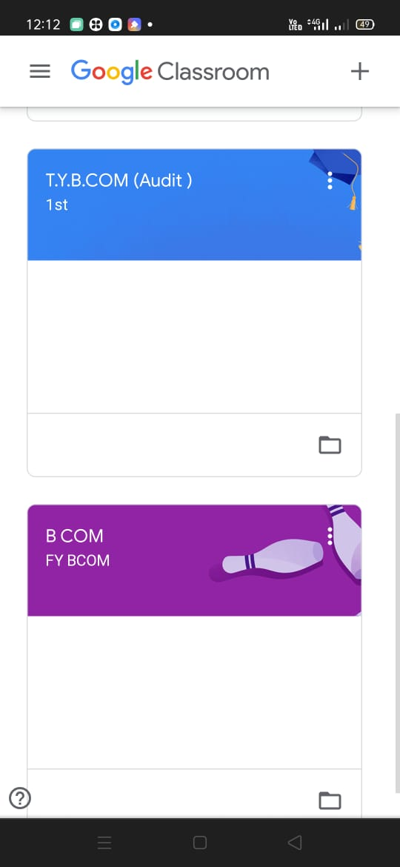

**Google Classroom of Dr. G. G. Mahajan**

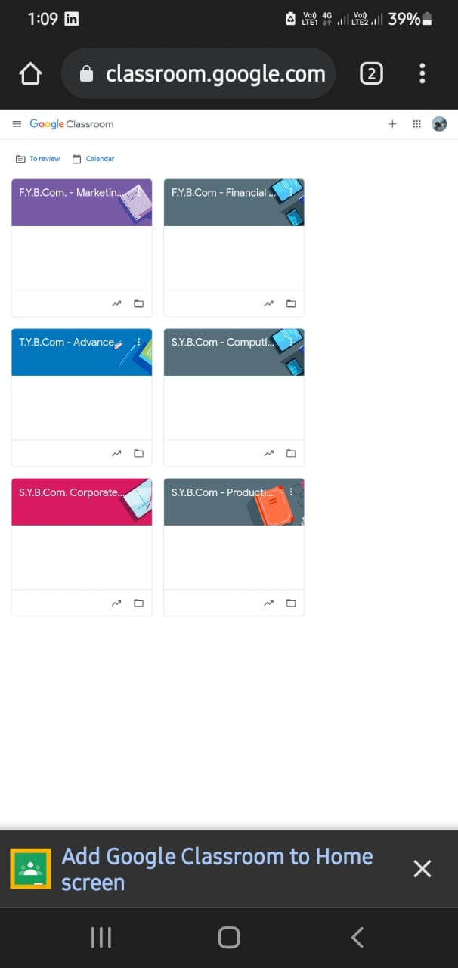

s